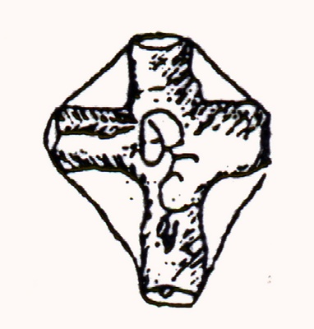
COMICS INTERNATIONAL

